Project Design Phase

Date | 19/02/2026
Team ID | LTVIP2026TMIDS66407
Project Name | AUTOMATIC CAR CATALOG SYSTEM FOR ENHANCED SHOWROOM MANAGEMENT
Maximum Marks | 2Marks

Proposed Solution Templete:

Project team shall fill the following information in the solution template

S. No | Parameter | Description
1 | Problem statement(problem to be solved) | An automated car catalog system in ServiceNow to streamline showroom management through real-time inventory updates and enhanced operational efficiency
2 | Idea/description | An automated car catalog system in ServiceNow to  Streamline showroom management through real-time inventory updates and efficient data handling.
3 | Novelty/uniqueness | An unique integration of automated car cataloging with ServiceNow to enable real-time intelligent showroom  Management and seamless service operations.
4 | Social impact/customer satisfaction | Enhancing showroom management with an automated car catalog system in ServiceNow improves customer satisfaction through faster service and accurate information, while promoting sustainable, tech-driven  Operations
5 | Business model(revenue model) | A subscription-based SaaS model offering automated car catalog and inventory management through ServiceNow to optimize showroom operations and  customer experience.

6 | Scalability of the solution | The solution is highly scalable, allowing seamless Integration of multiple showrooms and car models across regions within the ServiceNow platform.

Automated car catalog system For Enhanced Showroom Management

What is catalog system ?

A catalog system in ServiceNow is a feature that allows user to store quest IT or business services through a structured and user-friendly interface. It organizes services into categories, making it easy for users to find and request items like software access, hardware, or support. Each request triggers workflows for approval and fulfillment, streamlining service delivery.

Types:

- IT Service Catalog – Offers IT services like password reset, software install.
- Business Service Catalog–Provides HR, finance, and other non-IT services.
- Technical Service Catalog–Contains backend services used by IT staff.
- Hardware Catalog–Lists physical assets like laptops, monitors, phones.
- Software Catalog–Offers software products and licenses for request.
- Facility Catalog–Requests related to offices pace, maintenance, for equipment.

Car Catalog System
A Car Catalog System is an organized system (software or database, sometimes even a printed catalog) used to store, manage, and present detailed information about cars in a structured and searchable way.

Think of it as a digital showroom + database that keeps all car-related details in one place.

Meaning of Car Catalog System :
A Car Catalog System is a system that maintains records of cars such as:

- Brand and model
- Year of manufacture
- Price
- Specifications (engine, mileage, fuel type, transmission, etc.)
- Features and variants
- Availability or stock status
- Images and descriptions

It allows users (customers, dealers, or administrators) to view, compare, search, and manage car information efficiently.

Purpose of a Car Catalog System :
The main purposes are:

Organized Data Management
Stores car details in a structured manner, reducing manual work and errors.

Easy Search and Comparison
Users can search cars by brand, price, fuel type, or features and compare multiple cars.

Improved Customer Experience
Helps customers quickly find cars that match their needs and preferences.

Inventory Control
Dealers can track available stock, sold cars, and upcoming models.

Marketing and Sales Support
Displays car details attractively with images, specifications, and offers.

Time and Cost Efficiency
Automates catalog management and reduces paperwork.

Types of Car Catalog System :
- Manual Car Catalog System :

  - Uses printed brochures, files, or registers.
  - Information is updated manually.
  - Time-consuming and prone to errors.
  - Mostly outdated now.

- Digital (Computerized) Car Catalog System :

  - Uses software or databases to store car information.
  - Easy to update, search, and maintain.
  - Commonly used by dealerships and companies.

- Online Car Catalog System :

  - Web-based system accessible via the internet.
  - Customers can browse cars online.
  - Examples: car dealership websites, car-selling platforms.
  - Often includes filters, comparisons, and booking options.

- Mobile App–Based Car Catalog System :

  - Designed as a mobile application.
  - User-friendly and accessible on smart phones.
  - Supports notifications, favorites, and quick searches.

Advantages of a Car Catalog System :

Easy Access to Information :
Users can quickly view complete car details such as price, features, and specifications.

Time-Saving :
Searching and comparing cars becomes faster compared to manual catalogs.

Better Organization of Data :
Car information is stored in a structured and systematic manner.

Easy Updates :
New models, price changes, and feature updates can be added easily.

Improved Customer Experience :
Customers can compare different cars and make informed decisions.

Reduced Paperwork :
Minimizes the use of printed catalogs and manual records.

Supports Decision Making :
Helps buyers and dealers analyze options efficiently.

Disadvantages of a Car Catalog System :

Initial Setup Cost :
Developing and implementing the system can be expensive.

Technical Dependence :
Requires computers, internet access, or mobile devices.

Maintenance Required :
Regular updates and system maintenance are necessary.

Security Risks :
Digital systems may face data breaches or unauthorized access.

Training Required :
Staff may need training to use the system effectively.

System Failure Issues :
Hardware or software failures can disrupt access to information.

Milestone 1 : Service Catalog

Purpose:

- List of Services – Provides a clear list of all available IT/business services.
- Easy Access – Helps users quickly find and request services.
- Standardization – Defines standard service offerings and processes.
- Improved Communication – Clarifies what services are available and how to request them.
- Transparency – Shows service details like cost, time, and approval process.
- Self-Service Support – Enables users to request services without manual intervention.
- Better Service Management – Improves tracking, delivery, and performance of services.
- Customer Satisfaction – Ensures users receive consistent and reliable services.

Uses:

  - Streamlined Car Inventory Requests – Allows staff to request vehicle listings or updates with pre-defined forms.
  - Automated Vehicle On-boarding – Simplifies adding new car models to the digital catalog through workflow automation.
  - Real-Time Status Updates – Enables tracking of vehicle availability, maintenance, and delivery schedules.
  - Role-Based Access – Controls who can view or modify catalog details, ensuring data integrity.
  - Service Request Analytics – Provides insights into car-related service trends and showroom demands.

Activity 1: Create Catalog
- Open service now.
- Click on All >> search for Maintain Catalog.

- Click on Maintain Catalog under Catalog Definition.
- After opening Maintain Catalog Click on new.
- Give Catalog Name as “Mahendra ”.
- Application should be Global.
- Give description as it is a car showroom.
- Click on Submit.

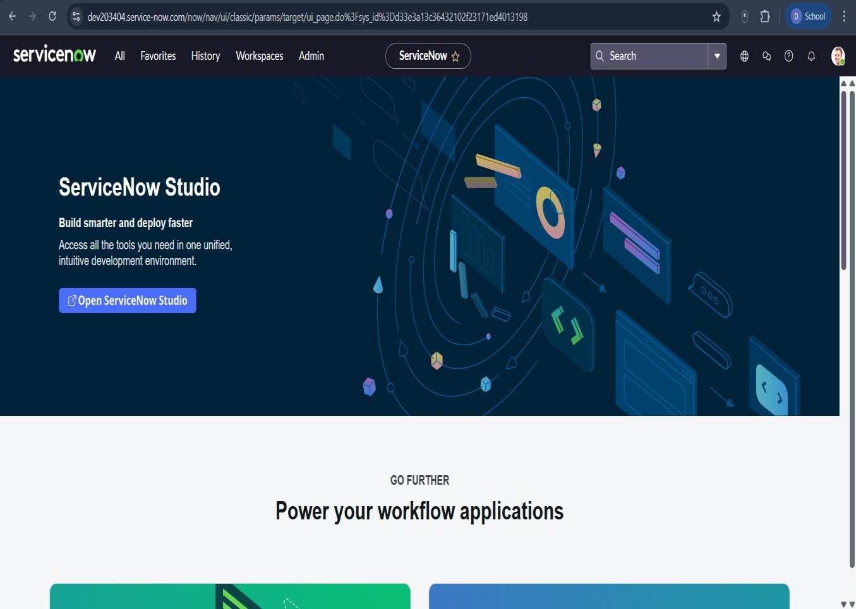

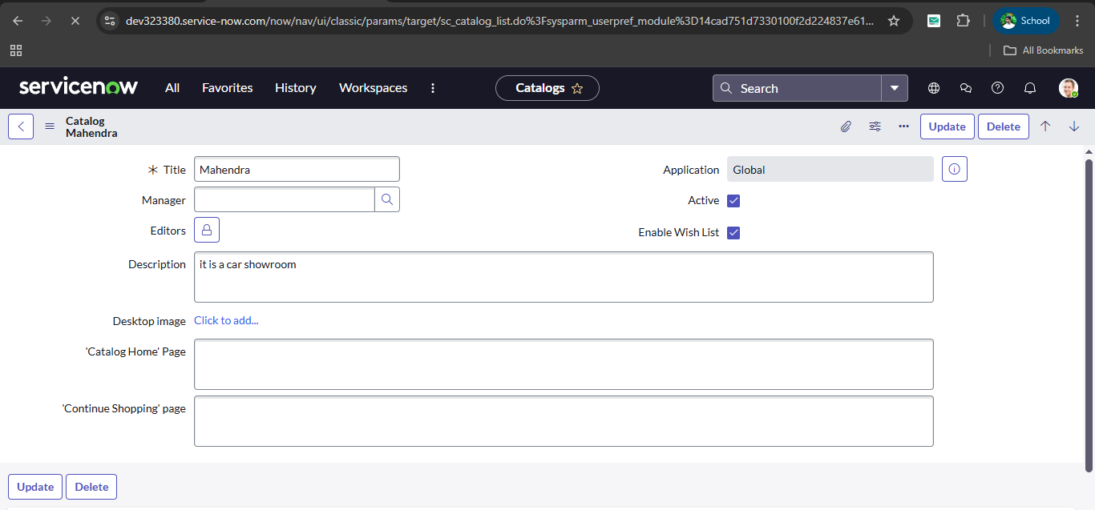

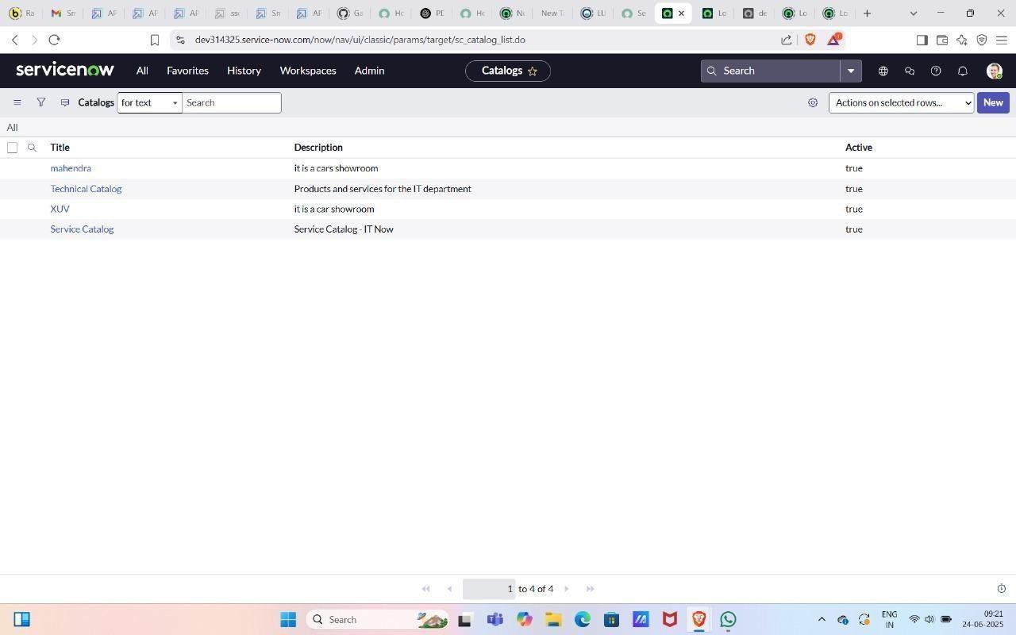

Activity-2 : Create Categories
- After submitting you can see the catalog Mahendra in the list.
- Open Mahendra Catalog Scroll down.
- Click Categories And Click on New.
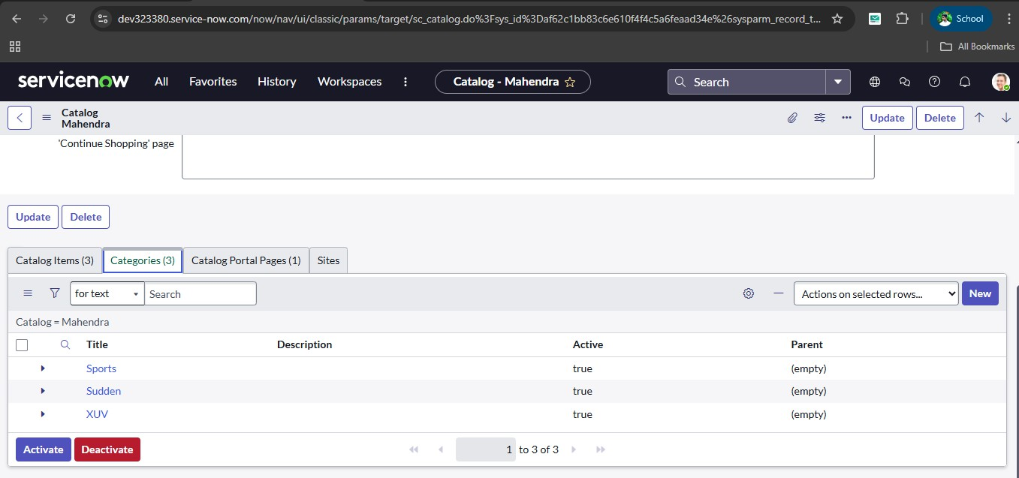
- Give Title as Sudden.
- Search and add catalog as Mahendra.
- Click on submit.
- Create two more categories as XUV and Sports.
- Click on Catalog Items and Click on new.
- Give it a name as polo.
- Select catalog as Mahendra.
- Select category as Sudden.
- Short description as Volkswagen Polo - Compact Hatchback with Superior Comfort and Efficiency.
- Give Description The Volkswagen Polo is a stylish and compact hatchback known for its agile performance, modern design, and premium features. Equipped with a 1.0-liter TSI engine, the Polo offers an impressive balance of power and fuel efficiency, making it an ideal choice for urban driving and longer journeys alike. This model includes advanced safety

features, a touchscreen infotainment system, and spacious seating, ensuring comfort and convenience for all passengers. The Polo stands out with its sporty look, LED headlights, and alloy wheels, reflecting Volkswagen’s commitment to quality and design.
- Click on Picture and add image.
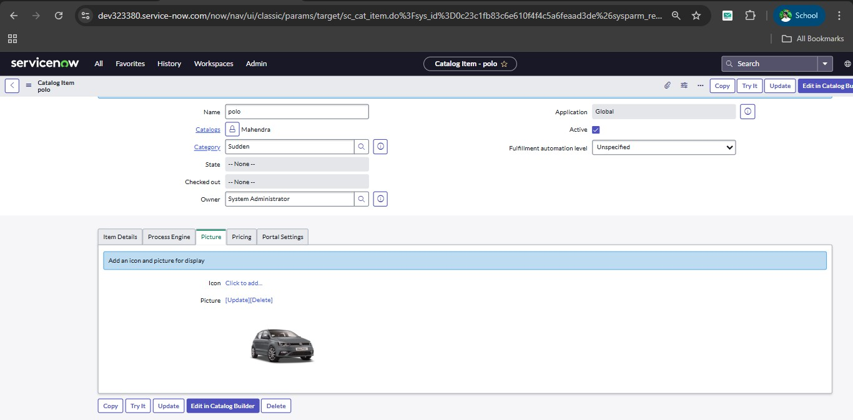
- Click on Pricing and give the price as 70 and recurring price 90
- Click on Portal setting and Select request method as Request.
- Click on Submit.
- Click on new and create one more catalog.
- Give it a name as Thar.
- Select catalog as Mahendra.
- Select category as XUV.
- Short description Mahindra Thar - 4x4 Off-Road SUV with Modern Features
- Description The Mahindra Thar is a rugged, off-road SUV built for adventure and performance. With a 2.0L mStallion petrol engine or a 2.2L mHawk diesel engine, it offers the perfect balance between power and fuel efficiency. The Thar comes with modern features like a touchscreen infotainment system, automatic climate control, and advanced safety features such as ABS and dual airbags. Its 4x4 drivetrain, high ground clearance, and water- wading capability make it a perfect choice for both city driving and off-road expeditions. Available in multiple trims, the Thar is designed to be the ultimate combination of style, comfort, and functionality.
- Click on Picture and add image.
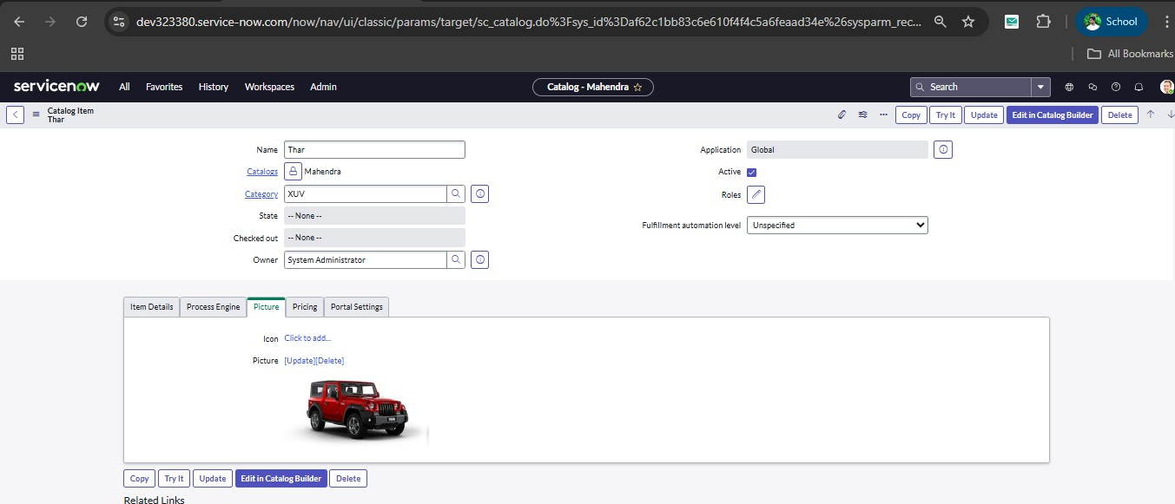
- Click on Pricing and give prices. 26 .price 150 to recurring price 170.
- Click on Portal settings and request method as Request.

- Give it a name as XUV700.
- Select catalog as Mahendra.
- Select category as Sports.
- Short description Mahindra XUV700 - The Ultimate SUV Experience.
- Description The Mahindra XUV700 is a premium, high-performance SUV known for its advanced technology, robust build, and superior comfort. Featuring a powerful turbo-petrol engine, it delivers an exhilarating driving experience. With futuristic design elements, a spacious interior, and cutting-edge safety features like ADAS, the XUV700 is built to offer an extraordinary ride. Key highlights include a 10.25-inch digital cockpit, panoramic sunroof, 7- seater option, and superior connectivity with Alexa built-in. Whether it's for city driving or off-road adventures, the XUV700 redefines the SUV experience.
- Click on Picture and add image of car.
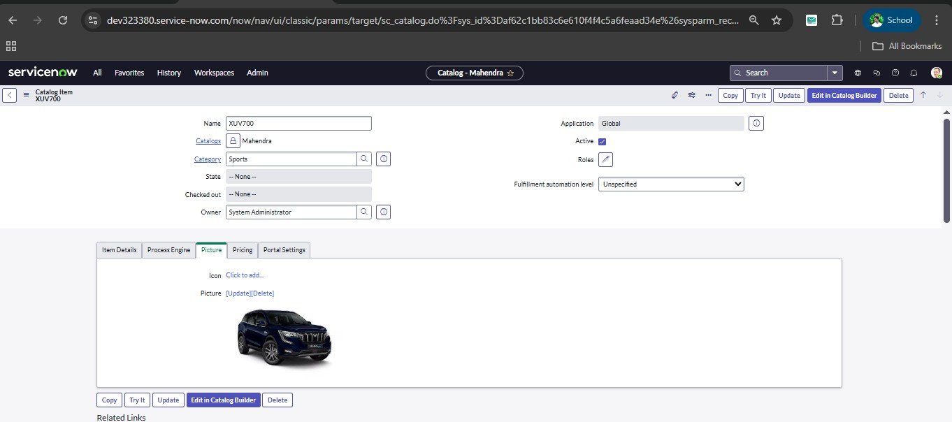
- Click on Pricing give price 200 to recurring price 211
- Click on Portal Setting and give the Request method as Request.
Milestone 2 : User Creation

Purpose :

  - List of Services – Provides a clear list of all available IT/business services.
  - Easy Access – Helps users quickly find and request services.
  - Standardization – Defines standard service offerings and processes.
  - Improved Communication – Clarifies what services are available and how to request them.
  - Transparency – Shows service details like cost, time, and approval process.
  - Self-Service Support – Enables users to request services without manual intervention.
  - Better Service Management – Improves tracking, delivery, and performance of services.
  - Customer Satisfaction – Ensures users receive consistent and reliable services.

Uses :

- Access Control – Allows users to log in securely.
- Authentication – Verifies user identity (username & password).
- Role Management – Assigns roles like Admin, User, Viewer.
- Security – Protects system from unauthorized access.

- Data Ownership – Links data to specific users.
- Accountability – Tracks user activities (audit trail).
- Personalization – Saves user preferences and settings.
- Collaboration – Enables multiple users to work in the system.

Activity 2 : Create a User

- Open service now.

- Click on All >> search for Users.

- Click on Users>> under System Security.
- Click on new, give userId as 01 and name as sales person and add the role emp1.
- Save and Submit.
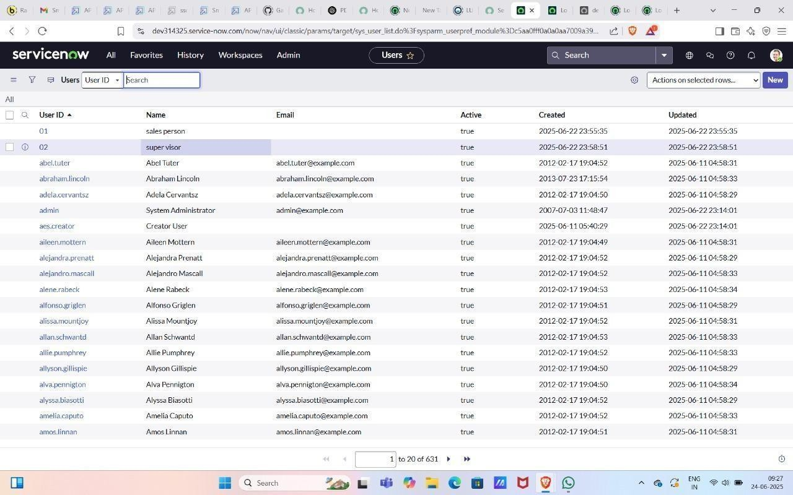
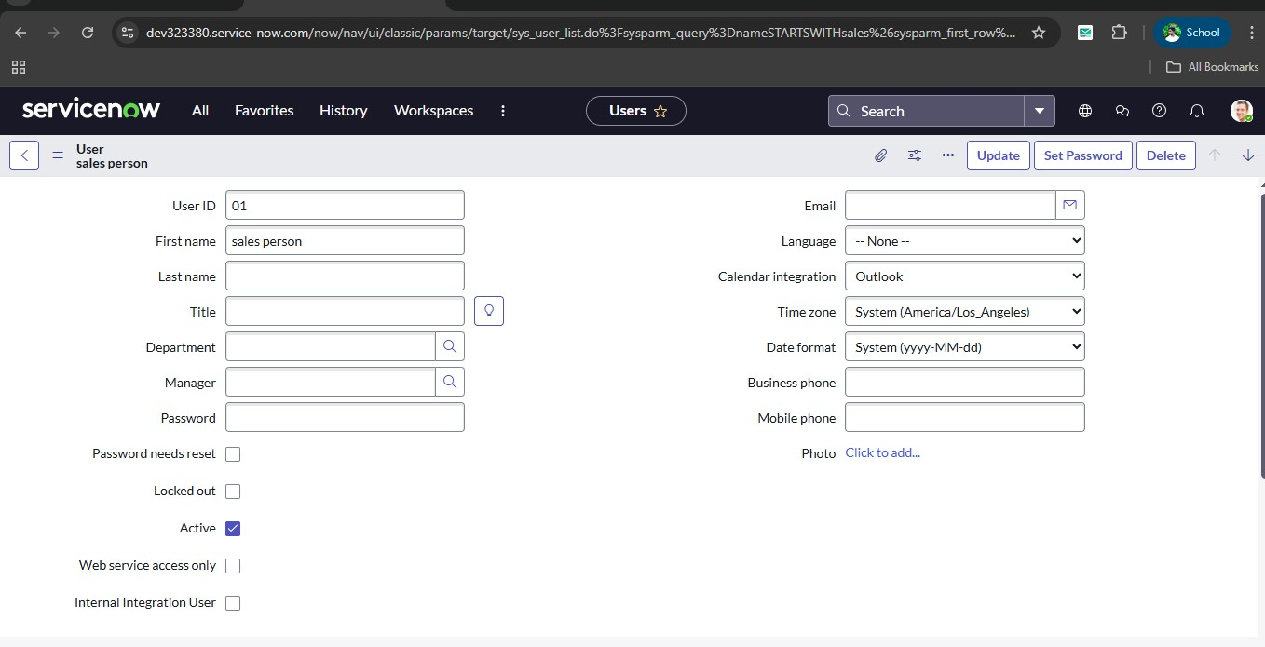

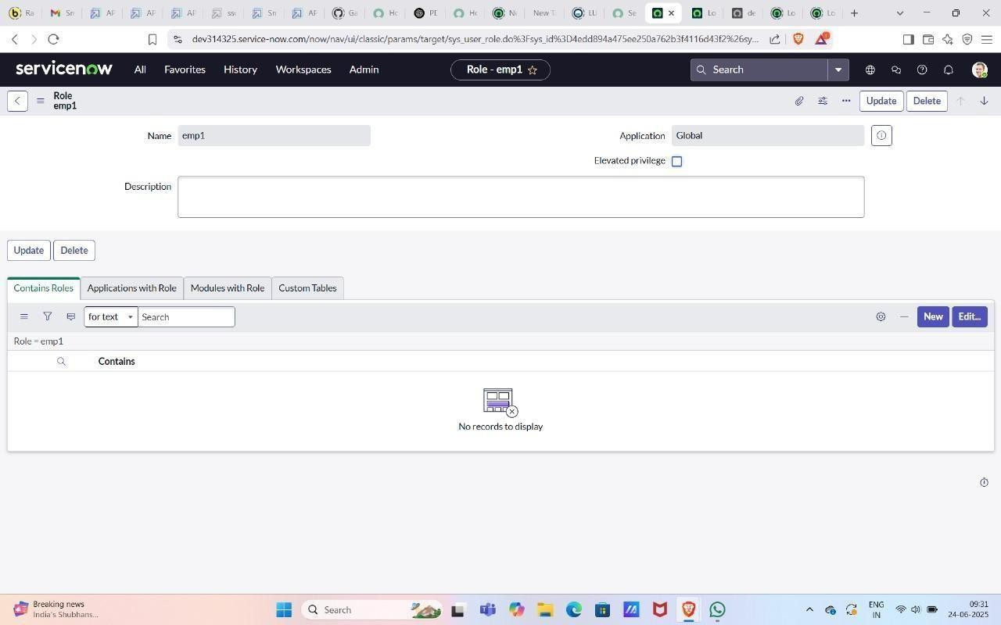

MileStone 3 : Role Creation

🎯 Purpose :
  - Access Control Management - Roles define what actions a user can perform (view, edit, delete, approve, etc.).
  - Security Enhancement - Limits users to only the permissions they need, reducing unauthorized access.
  - Simplifies Administration - Instead of managing permissions for each user, admins assign roles once and reuse them.
  - Supports Organizational Structure - Roles can match job positions like Admin, Manager, Employee, Developer, etc.
  - Audit and Compliance - Helps track who has what access, which is useful for audits and security policies.

Uses :
- Access Control - Role creation helps control what actions a user can perform in the system such as viewing, editing, or deleting data.
- Improves Security - It ensures users get only the permissions required for their job, reducing unauthorized access and protecting sensitive information.
- Simplifies Administration - Administrators can assign permissions to roles once and then assign those roles to multiple users, saving time and reducing errors.
- Supports Organizational Structure - Roles can be created based on job positions like Admin, Manager, or Employee, ensuring each person accesses only relevant data.
- Helps in Auditing and Tracking - Role-based access makes it easy to monitor user activities and check which permissions are assigned, which is useful for security and compliance.

Activity : Create a Role

- Click on the Servicenow logo and click on all and search for roles.
- Click on Roles >>Under system security.
- Click on new and give the name as emp1.



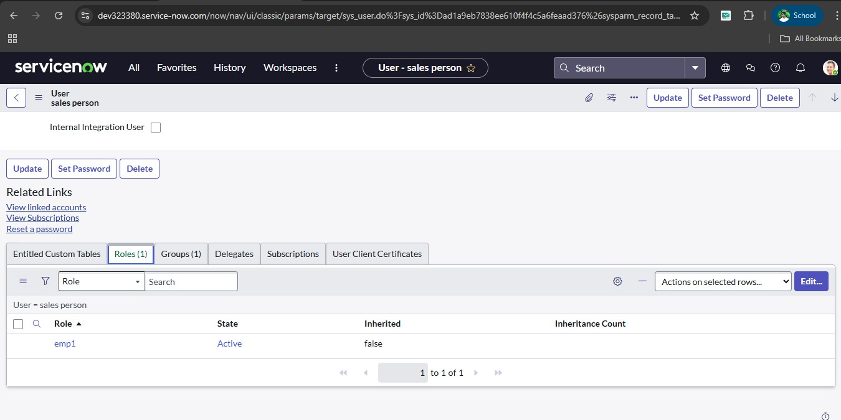
Milestone 4 : Group Creation
Purpose :

To Control Access
Role creation ensures users can only access the information and functions they are allowed to use.

To Improve Security
It prevents unauthorized users from accessing sensitive data and reduces the risk of misuse.

To Simplify Permission Management
Instead of assigning permissions individually, administrators create roles once and assign them to many users.

To Support Organizational Structure
Roles reflect job positions such as Admin, Manager, or Employee, ensuring proper data access.

To Enable Efficient System Management
Used in databases, enterprise software, and cloud platforms like Amazon Web Services, Microsoft Azure, Google Cloud Platform.

Uses :

- Access Management
Roles control what users can view, edit, create, or delete in the system.
➡ Prevents unauthorized access.

Improves Security
Users receive only the permissions needed for their job.
➡ Protects sensitive data and reduces misuse.

Simplifies Administration
Permissions are assigned to roles once and reused for many users.
➡ Saves time and reduces errors.

Supports Organizational Structure
Roles are created based on job positions like Admin, Manager, Staff, etc.
➡ Ensures proper data access for each department.

Helps in Auditing
Easy to track which role has what permissions.
➡ Useful for monitoring and security checks.

Improves Scalability
When new users join, simply assign an existing role.
➡ Makes management easier in large systems.
Activity : Create a Group

- Click on All>>Search for groups.
- Click on groups>>under Security System.
- Click on new and give the group's name as showroom.
- Give the group manager as Abraham lincoln. And Submit.
- Add group members as Salesperson, Salesperson2 and 3.And update.

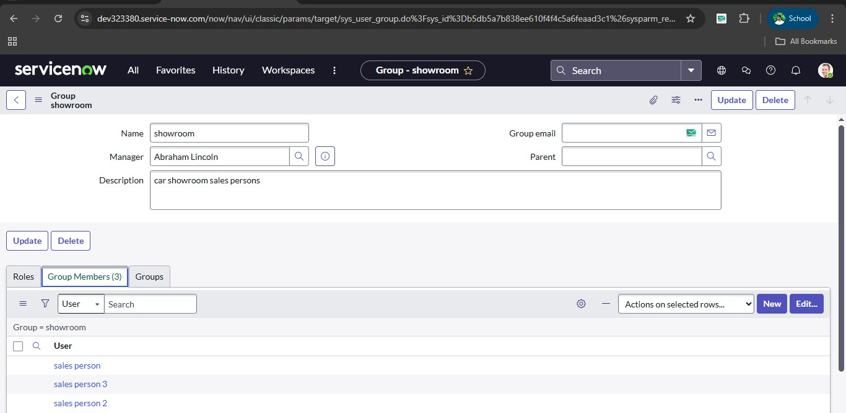

Milestone-5 : Table Creation

Purpose :

To Control User Access
It ensures that users can only access the data and functions they are permitted to use.

To Improve Security
Prevents unauthorized access and protects sensitive information by limiting permissions.

To Simplify Permission Management
Administrators create roles once and assign them to multiple users instead of setting permissions individually.

To Reflect Job Responsibilities
Roles are created according to positions like Admin, Manager, Employee, etc., ensuring proper access levels.

To Support Efficient System Administration
Makes it easier to manage users, especially in large organizations and multi-user systems.

Uses :

Controls User Access
Roles define what actions a user can perform (read, write, edit, delete).
➡ Prevents unauthorized access to data.

Improves System Security
Users get only the permissions required for their work.
➡ Reduces data misuse and protects sensitive information.

Simplifies Administration
Permissions are assigned to roles once and reused for many users.
➡ Saves time and reduces configuration errors.

Supports Organizational Structure
Roles match job positions like Admin, Manager, Staff, etc.
➡ Ensures each employee accesses only relevant information.

Helps in Monitoring and Auditing
It becomes easy to track who has which permissions.
➡ Useful for security checks and compliance.

Improves Scalability
When new users join, assign an existing role instead of creating permissions again.
➡ Efficient for large organizations.
Activity : Create a Table

- Click on All>>Search for Tables.
- Click on Tables>>under System definition.
- Click on the new give name as cars fulfillment.
- Give extended table as Task table.
- Save and Submit.

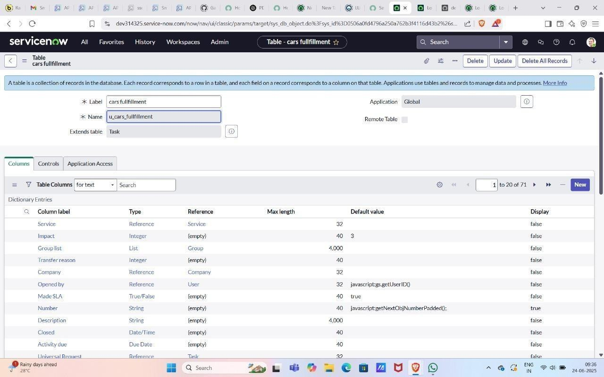

Milestone-6 : Workflow

Purpose :

To Organize Tasks Properly
Workflow defines the correct order of activities so work is completed step-by-step without confusion.

To Improve Efficiency
It reduces delays, duplication of work, and unnecessary steps, making the process faster.

To Ensure Consistency
Every time the process runs, it follows the same steps, producing uniform and reliable results.

To Improve Accountability
Workflow clearly shows who is responsible for each step, making it easier to track progress.

To Support Automation
Workflows help organizations automate repetitive tasks, saving time and effort.

To Enhance Communication
Each stage of the workflow shows how information moves between departments or people.

Uses :

Organizes Work Process
Workflow arranges tasks in a proper sequence so work is done in the correct order.
➡ Avoids confusion and missing steps.

Improves Efficiency
It reduces delays, repetition, and unnecessary work.
➡ Saves time and increases productivity.

Ensures Consistency
Every time the process runs, it follows the same steps.
➡ Produces uniform and reliable results.

Helps in Tracking Progress
Workflow shows which step is completed and what is pending.
➡ Makes monitoring easier.

Improves Accountability
Each stage has a responsible person or department.
➡ Helps identify who handles each task.

Supports Automation
Workflows can be automated in software systems.
➡ Reduces manual effort and errors.

Enhances Communication
Shows how information moves from one stage to another.
➡ Improves coordination between teams.

Activity : WorkFlow Assignment to Mahendra service Catalog.
  - Navigate to Homepage.
  - Click on all search Workflow Editor.
  - Click on New Workflow.
  - Under the name field search for Test Select that record.
  - After creating workflow you can see begin and end.
  - Drag the approval user from core and give name as sales.
  - Give the user as a sales person
  - Drag the approval user from core and give name 2nd level.
  - Add a user as supervisor.
  - Drag create task from core and give name as car company
  - Give task type car fulfilment table and priority-1.
  - Give task values from values
  - Set values as car status Ready to Pickup.
  - State Closed Complete and submit.
  - Drag the create task from core and give it name as car production.
  - Give task type car fulfilment table and priority-1.
  - Give task values from values
  - Set values as car status deployment failed.
  - State closed Incomplete.And Submit.
  - Drag Notification from core and give name as Booking Notification.
  - Add To user as Abraham Lincoln and group as Showroom.
  - Give the subject as car showroom and message
<html>
<body style="font-family: Arial, sans-serif;">

<!-- Background Logo Wrapper -->
<div style="background-image: url('${C:\Users\saipr\OneDrive\Pictures\Screenshots\Screenshot 2024-10-28 125727.png}'); background-size: contain; background-repeat: no-repeat; background-position: center; padding: 20px; text-align: center;">

<!-- Overlay Content -->
<div style="background: rgba(255, 255, 255, 0.8); padding: 20px; border-radius: 8px;">
<h2 style="color: #333;">Car Request Notification</h2>
<p style="color: #555;">
Hello, your request for a car model has been submitted and approved.
</p>

<!-- Dynamic Fields -->
<p><strong>Requested Car:</strong> ${requested_for}</p>
<p><strong>Status:</strong> ${approval}</p>

<p style="color: #333;">Thank you for choosing Mahendra!</p>
</div>

</div>

</body>

</html>
  - Submit.
  - Drag the Notification and give the name as car reject.
  - Add To user as Abraham Lincoln and add group showroom.
  - Give the subject as a car showroom.
  - Give a message as car booking approval is rejected.
  - Submit and end
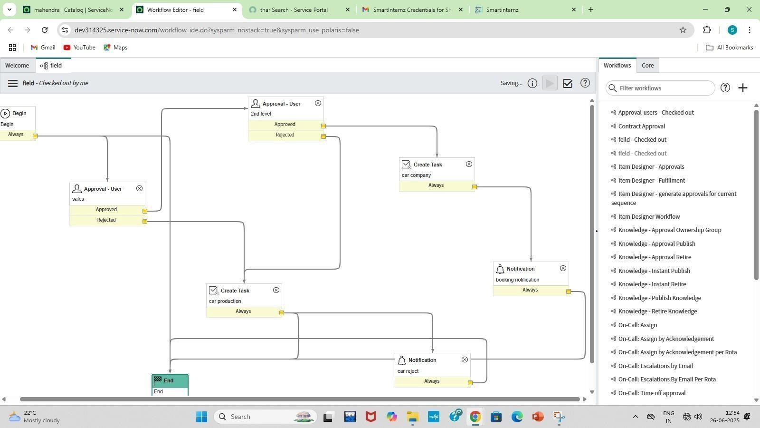
Milestone -7 : Service Portal

Purpose :

Single Access Point for Services
It provides one central place where users can request services, raise tickets, and check updates.

Improves User Experience
Service portals are designed to be simple, user-friendly, and accessible from anywhere.

Enables Self-Service
Users can solve problems using knowledge articles, FAQs, or automated tools without contacting support.

Speeds Up Service Requests
Requests are submitted online and automatically routed to the right department.

Improves Communication
Users can track ticket status, receive notifications, and interact with support teams.

Supports Automation
Many tasks like approvals, routing, and notifications are automated through the portal.

Uses :

Service Request Submission
Users can request IT services, software access, or resources through the portal.
➡ Eliminates manual requests and emails.

Incident Reporting
Users can report issues or problems and create support tickets online.
➡ Speeds up problem resolution.

Self-Service Support
Provides knowledge articles, FAQs, and solutions so users can fix issues themselves.
➡ Reduces workload on support teams.

Ticket Tracking
Users can check the status of their requests or complaints anytime.
➡ Improves transparency and communication.

Centralized Access to Services
All services are available in one place instead of different systems.
➡ Makes it easy for users to find what they need.

Supports Automation
Requests can be automatically routed for approval or assignment.
➡ Saves time and reduces manual work.

Improves User Experience
Provides a simple, user-friendly interface accessible from anywhere.
➡ Increases efficiency and satisfaction.

Activity : Searching created catalog are available in service portal
- Check the cars are available in the service portal.And order it.
- To open a service portal copy the url of your instance up to com/ and give sp press enter for example(https://dev266346.service-now.com/sp).
- Search the catalog item which you are created.

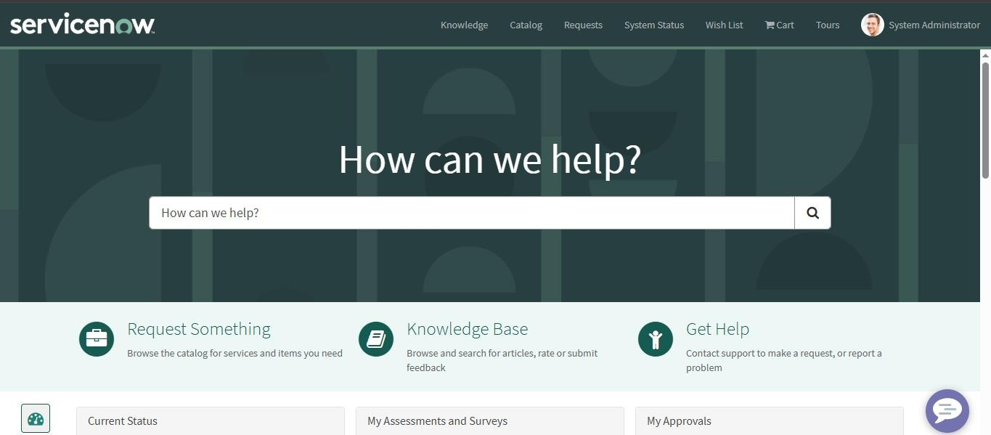

- Search for thar. And order it.
- After ordering the car you get a request number and Delivery date.
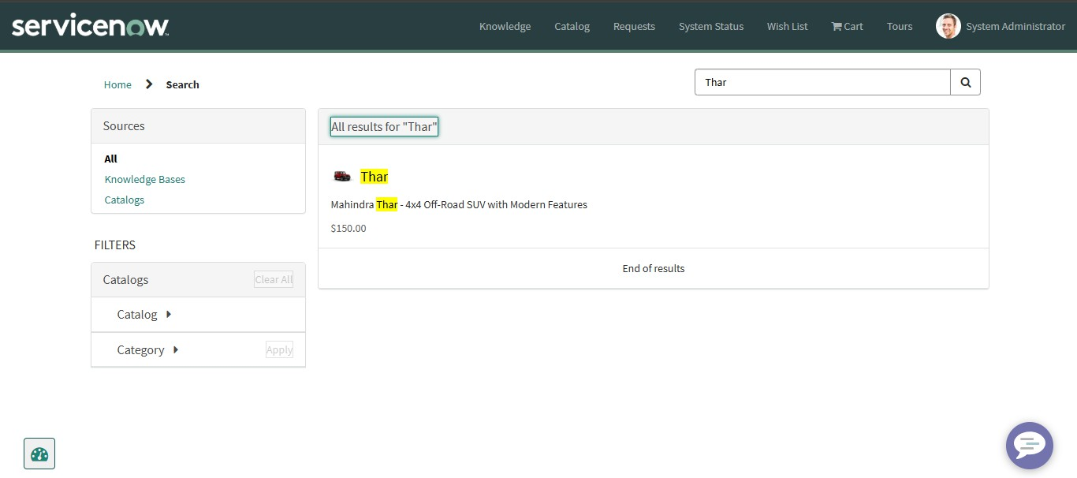

- After requesting an item and the request shown in Task table.
- In Task we Approve or reject the request.

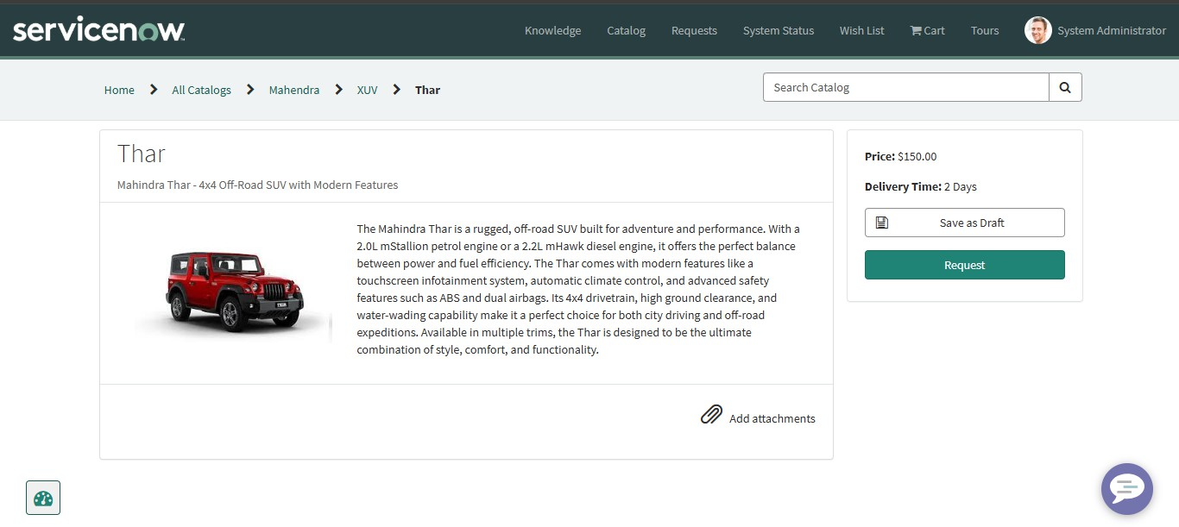
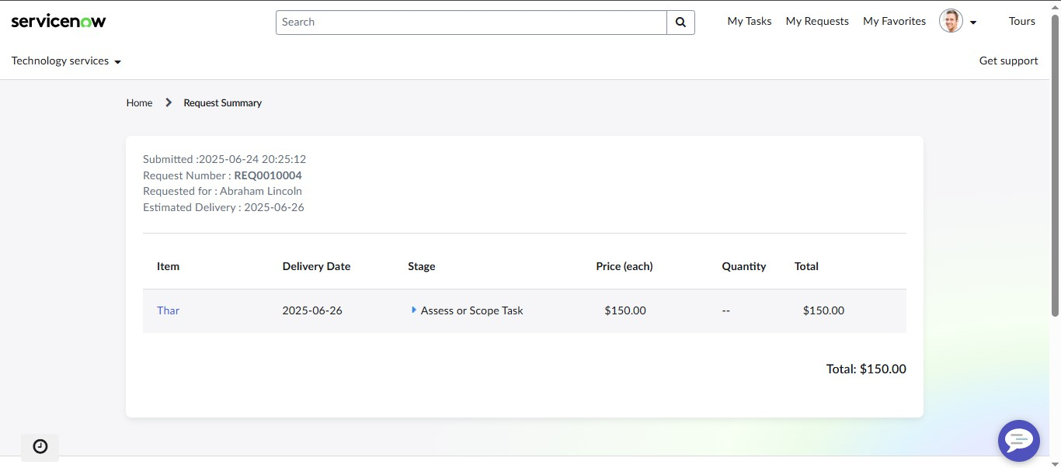

Milestone-8 : Result

After ordering the car request is approved you get a mail the order will be delivered. And Based on your order being approved or rejected you will receive a rejected mail.

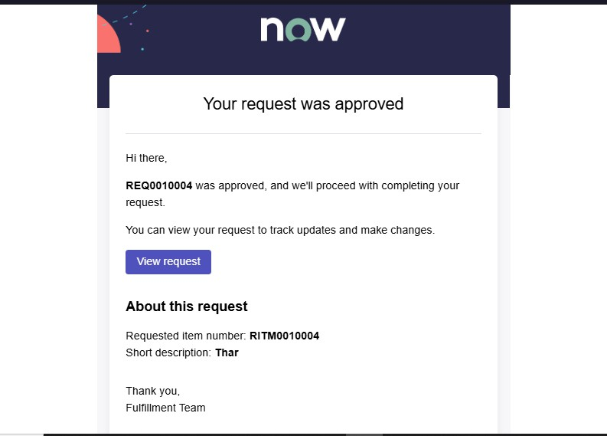

Conclusion :

The Car Catalog System project for a car showroom in ServiceNow successfully addresses the need for a streamlined, automated approach to managing car catalog items, customer requests, and approval workflows. By organizing car models into easily navigable categories and leveraging ServiceNow's powerful automation features, the system enhances operational efficiency, reduces manual intervention, and improves customer satisfaction.

